

*Seeing Racial Ethnic Disparities*

in the Massachusetts

Juvenile Justice System

Discussion Guide

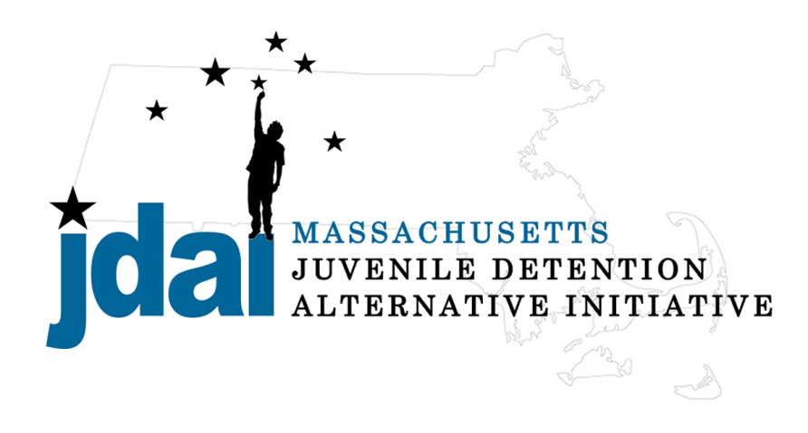

JDAI is supported by 

***How this Discussion Guide is set up…***

**Preparation for Facilitators … p. 3**

**Beginning the session … p. 6**

**Introduction to Person, Role System perspective … p. 7**

**Tree Analogy … p. 8**

**Person … p. 9**

**Role … p. 10**

**System … p. 11**

**Accountability Pathway... p. 12**

**Action Planning … p. 13**

**Sample Agenda … p. 14**

***Do your homework… be prepared.***

* Review the *Seeing RED* video.
* Complete implicit bias tests, <https://implicit.harvard.edu/implicit/takeatest.html>
* Be prepared to discuss your own experience with the video and implicit bias test.
* Review additional resources provided on the JDAI website.
* Come prepared to the session to engage.
* Use this guide to support the facilitated discussion with the group.
* Make sure everyone is heard.

***Understand the History, at least on a high level...***

* African American Citizenship Status from 1619 to 1985
* Historical Timeline
  + Civil War, 13th Amendment, Reconstruction and the Freedmen’s Bureau, 14th Amendment, 15th Amendment, The Black Codes, Jim Crow Laws, Plessy v. Ferguson, Brown v. Board of Education,
* Relics of Slavery
  + Explosion of the Mass Incarceration System, The War on Drugs, Federal Housing Authority Redlining and Residential Segregation, Income and Wealth Disparities by Race, Consequences of Bias

**System:** Where you sit in a system can influence how you see the connections and how you exercise leadership in making change.

**Role:** What role as a professional you hold can create formal or informal authority to influence a task/change or the conversation.

**Person:** Who you are, as person, family-member, community member, with experiences influences your daily and long-term outlook.

***Setting up a screening & Facilitators...***

* Fill out Screening Session Form
* A member of our team will work with you on identifying Facilitators.
* JDAI Massachusetts encourages that two trained facilitators are used to ensure a productive discussion.
* It is also recommended that facilitators are diverse. Divers in gender, role/system/agency/community/family member and race and ethnicity.
* Schedule two planning calls with facilitators to discuss strategy, philosophy and who will facilitate which portion of the discussion.
* Discuss who, will do what, where and when...

***Participants...***

* Who is part of the audience?
* Is the group from the same organization or, is this an inter-agency training?
* Are there stakeholders from community, agencies and systems?
* Is there a power differential in the room?

***Using meaningful data...***

* The Relative Rate Index (RRI) relates each racial/ethnic group’s rate of contact with the juvenile justice system to that of the white youth group. The Relative Rate Index is a means of comparing the rates of juvenile justice contact. Each relative rate is dependent on the decision point that comes directly before what is being measured. The RRI provides a single index number that indicates whether there is disparity.
* Think about the composition of the group and what data would be most relevant to them.
* Prepare ahead of time to get the data you need.
* Determine your goal with the data.
* Answer what the key takeaway or headline is from each data slide.
* Be able to respond to common distractors about the data.
* Where to get data
  + JDAI
  + DESE
  + Other

***Logistics***

***Location:*** Scope out the venue ahead of time.

* See what options you have for darkening the room and showing the documentary on a screen or wall
* Are there parking restrictions that you should note in the invitation?
* ***It’s good to get some housekeeping done right after people arrive. Let people know where the restrooms and refreshments are. Give a general idea of breaks and when the session will end.***
* ***Write up Ground Rules on Easel Paper***

***Technology, make sure you have the equipment to show the film. The video lives online; is the equipment internet-enabled? Does the sound system provide appropriate volume?***

* PowerPoint on Flashdrive
* Laptop
* Speakers
* Projector
* Seeing Red video - Flashdrive or Wifi

***Get organized. Make copies of sign in sheets and action plans. You can also make copies of the further resources or any of our other materials – or simply refer people to the website for more info.***

***Paper handouts***

* Sign-in sheet
* Evaluations
* Updated participant agenda
* Action Planning Worksheets
* Further Resources Sheets (2)
* Modified Data handout
* Equity vs Equality Handout

***Other needed materials...***

* Green/Yellow/Red cards
* Accountability Pathway
* Nametags
* Easels & Paper
* Markers
* Candy or fidget toys for tables

**RED**

YELLOW

**GREEN**

**Take the temperature of the room**: Ask the audience to rate their individual comfort level, for instance, when taking about RED.

**RED** - being not comfortable talking about RED

Yellow – being uncertain or somewhat comfortable

**Green** - being very comfortable with the discussion.

Participants can raise their hands and show fingers, or go around the room and quickly say their number, depending upon the size of the room.

This technique can be used multiple times and in different ways...

* + Initial reading of the group
  + Check-ins
  + Readiness for change...
  + Etc...

**Ground Rules**

1. *Given the topic, ground rules are essential for establishing trust before any discussion.*
2. *Come prepared with ground rules, possibly written on large paper, but welcome people adding more rules onto those you offer.*
3. *Clearly ask the room, "Is there anything offered in these group rules that anyone cannot agree with?"* 
   * *It is easier for people to say "yes," over "no," so the inverted question invites people to tell you what's missing.*

***Beginning the session…***

***Each person is coming from a unique perspective…review these with the group***

* Participants will be coming with varied personal experiences with *RED*. A group of mixed stakeholders may not have gained group trust to share openly about challenges they see.
* Not all people present are ready to have this conversation. A group from a single stakeholder agency may play out internal power struggles within their workplace during the discussion.
* Preparedness for change. When possible, investigate who in the room holds the actual or perceived power, and be prepared for these partners.

**Introduction to Person, Role, System…** Ask participants to introduce themselves in terms of **person - role – system**; facilitators should go first modeling the introduction.

Thank you for taking on this important job! The point of this session is to talk about how race and ethnicity affects the juvenile justice system and what we can do about it – not to critique the video or to enter into a broad discussion about every manifestation of racism in America. The facilitator’s should steer the conversation back to possible solutions.

**System:** Where you sit in a system can influence how you see connections and how you exercise leadership in making change.

**Role:** What role as a professional you hold can create formal or informal authority to influence a conversation, task or effect change.

**Person:** Who you are, as a person, family-member, community member, with experiences influences your daily and long-term outlook.

**Person, role, system…** This guide suggests focusing the conversations using a multilevel perspective: Person- Role- System, which is also reflected in the film. A section is dedicated to each.

**Takeaway message:** There is an ebb and flow to how each of these influences the other, for instance who we are as a person influences how we approach our role, and how our role ripples through the system. Likewise, the way the system is set up may really constrain our role, and affect how we are as a person. It is about reflecting on all three and the interrelationships.

**Discussion Questions** (This guide offers sample questions to engage the participants in a discussion)

**These questions can be used to prep the audience or discuss general responses to the video.**

1. *What are some structural causes of inequities? What are some individual causes?*
2. *What does this discussion suggest for possible policy or practice interventions to reduce racial disparity?*

**Tips…** (Here you will find practical tips for addressing issues which may come up)

* Intro the Person, Role, System perspective
* Set expectations for agenda, including breaks
* Intro the video
* Ask the participants to think about these questions as they watch…
* Facilitate discussion and clarify questions

**Common reactions to talking about *RED*…** We’ll identify common reactions a facilitator may encounter when talking about *RED*. These reactions are not mutually exclusive to person, role or system. You may experience any of these reactions at any point during the discussion. The disparities increase at almost every decision point, so all system actors have to own this and work creatively to address issues.

**One challenge in facilitating discussions about *RED* is conversations can easily turn to the impact of *RED*, the leaves on the tree, and your role is to redirect the discussion to re-focus conversation to the root causes and draw out action steps.**

Maryland Departent of Juvenile Services (DJS)

**Leaves of the tree** represent the effects, or impact, of *RED*. These may include issues such as poverty, etc.

The **tree trunk** represents the core problem, *RED*.

The **roots of the tree** represent the causes of *RED*. These may include implicit bias, harsher treatment at key contact points, systems pipeline, failure to distinguish high need from high risk, disproportionate investment between incarceration & community based resources.

**Tree Analogy**

Before embarking on this journey, please consider the tree analogy to help frame your understanding and facilitation of the discussions.

**Person:** In this section, the objective is to understand and reflect on the group’s initial personal reaction to the information conveyed to them in the video. This is where the discussion starts. Generate a solution based conversation that will help to inform the rest of the session.



**Discussion Questions…**

1. *What is your initial response to this film? (The Big Idea Question)*
2. *What changed your thinking on RED in any way? What hasn’t changed? (Barrier Question)*
3. *What are your reactions to the idea that we all have implicit biases that impact the decisions that we make? (Consequence Question)*
4. *What inspired you about this film? (Solution Oriented)*
5. *We all have concerns about the safety of the children in our lives. What do you think it’s like for parents of youth of color to realize that their children are at higher risk of being arrested or criminalized?*

**Tips…**

* Stay calm
* Ignoring a challenger may only make them more forceful
* Acknowledge the emotion or sentiment behind the comment
* Ask if the comment was a response to your question- if so, was it a fair response?
* Ask the room if anyone wants to respond, maybe before you do. The participants likely will support you.

**Common reactions to talking about *RED*…**

*DENIAL* – e.g. “*I look at each case individually so there can’t be any bias.*” This may well be, but be aware we all have bias. Try to learn why data suggests overrepresentation or disparity in a decision point or process.

*DEFENSIVENESS -* People may suggest you want to collect data to use it against them. People are afraid to be called racists. Avoid judgment; focus on solutions, use data to develop goals.

*The “BLAME GAME”* - Blaming parents, media, videogames, rap music; discounting the relevance of race. Blaming the system actor earlier in the system for ‘*sending the wrong kids*. (e.g. police arrest too much)’ There is no disparate treatment; “*we have black judges and a black President.*” Focus on what you can control. Use research to deal with myths.

**

**Role:** In this section, we want to discuss the professional roles we all fill in the lives of youth (e.g. a probation officer, a judge, a DYS staff, a teacher, a police officer, etc.). In our roles, we all have actions or steps we can take to increase equity and reduce disparity, at each step in the process.

**Discussion Questions…**

1. *We’ve seen that bias can happen even where people are not conscious of any prejudice. What are some ways we can become more aware and try to spread fairness?*
2. *Remember what Meghan Guevara said in the film about knowing this is a huge problem but we know it is exacerbated by many small decisions that we make as professionals every day,…. that we can make an impact? From your role in the system, where do you see a place to make a difference?*
3. *This film makes the case that RED is an issue everyone should be concerned about, even if in our role we are not involved with the court system. Do you agree? Why or why not?*

**Tips…**

* Try to keep the frame on the role that each system stakeholder can play.
* Participants may try to blame other actors (e.g., “if the police didn’t arrest the youth, we wouldn’t have this problem….”); while others may want to talk about poverty…
* Work to help the audience understand that to do this work well, we all have to be able to just look in the mirror, or at our little corner of the system and ask is there something that we could do better in our role.
* Parking lot issues that the group cannot control and refocus on reasonable action steps.

**Common reactions to talking about *RED*** …

*AVOIDANCE* – e.g. “*It’s not about race, it’s about poverty.”* Here is where people try to redirect discussions to big social issues instead. Although poverty is interconnected to discussions about race and ethnicity in the United States, try to keep focus on what you can control – developing measurable improvements.

*CULTURE OF POLITENESS -* No one wants to say anything in meetings that may offend or make some feel uncomfortable, therefore, no one talks about the real race issues. They talk about the weather even politics and everyone is polite and nice. Race is a sensitive subject, be professional, respectful, and transparent in the conversations. Honest conversations are a major part to leading the conversation and helping to create change.

**System:** In this section we want to talk about how the systems can impact youth, and the systemic changes that might need to be addressed to improve outcomes for youth of color in Massachusetts.



**Common reactions to talking about *RED***…

*MOTION WITH OUT MOVEMENT* - People have genuine concern over racial disparities and determination to do something about it, but work is unfocused. Meeting to meet yet there is no real impact to show for it and kids of color are still faring poorly in the system. Efforts must be strategic and measurable.

*DATA WITHOUT DIRECTION* - Analysis paralysis. Lack of knowledge on how to strategically use the data collected. Too much data, people do not understand data. Combine data with narratives that describe what data means in practical terms. Make data as friendly as possible as it will be a powerful tool to help.

**Discussion Questions…**

1. *This film posits that disparities are a result of a system. Do you agree with this interpretation of the data? Why or why not? If not, what other things do you think are contributing to these disparities? (this question could help surface skeptics and give a chance to address their perspective)*
2. *What things are happening in your workplace (or your community) where you’d like to make a difference?*
3. *We heard about a number of strategies to address RED at the systemic level. Which one(s) do you think will have the biggest impact? What could you do personally to support these ideas?*

**Tips…**

* This is an area where many people may not feel like an expert. Reference the additional readings and national strategies as appropriate next steps for some in the room to further educate themselves.
* Try to keep the conversation productive and not about blaming the other systems (e.g. blaming the education or child welfare systems). Redirect to how “the systems” could work better together, such as was shown in the film for the Dually Involved Youth work in Hampden County.

**Are We Ready? I’m ready to commit to action steps to increase equity within Suffolk County.**

* Red 🡪 I Disagree
* Yellow 🡪 I’m neutral / not sure
* Green 🡪 I agree

**The Accountability Pathway**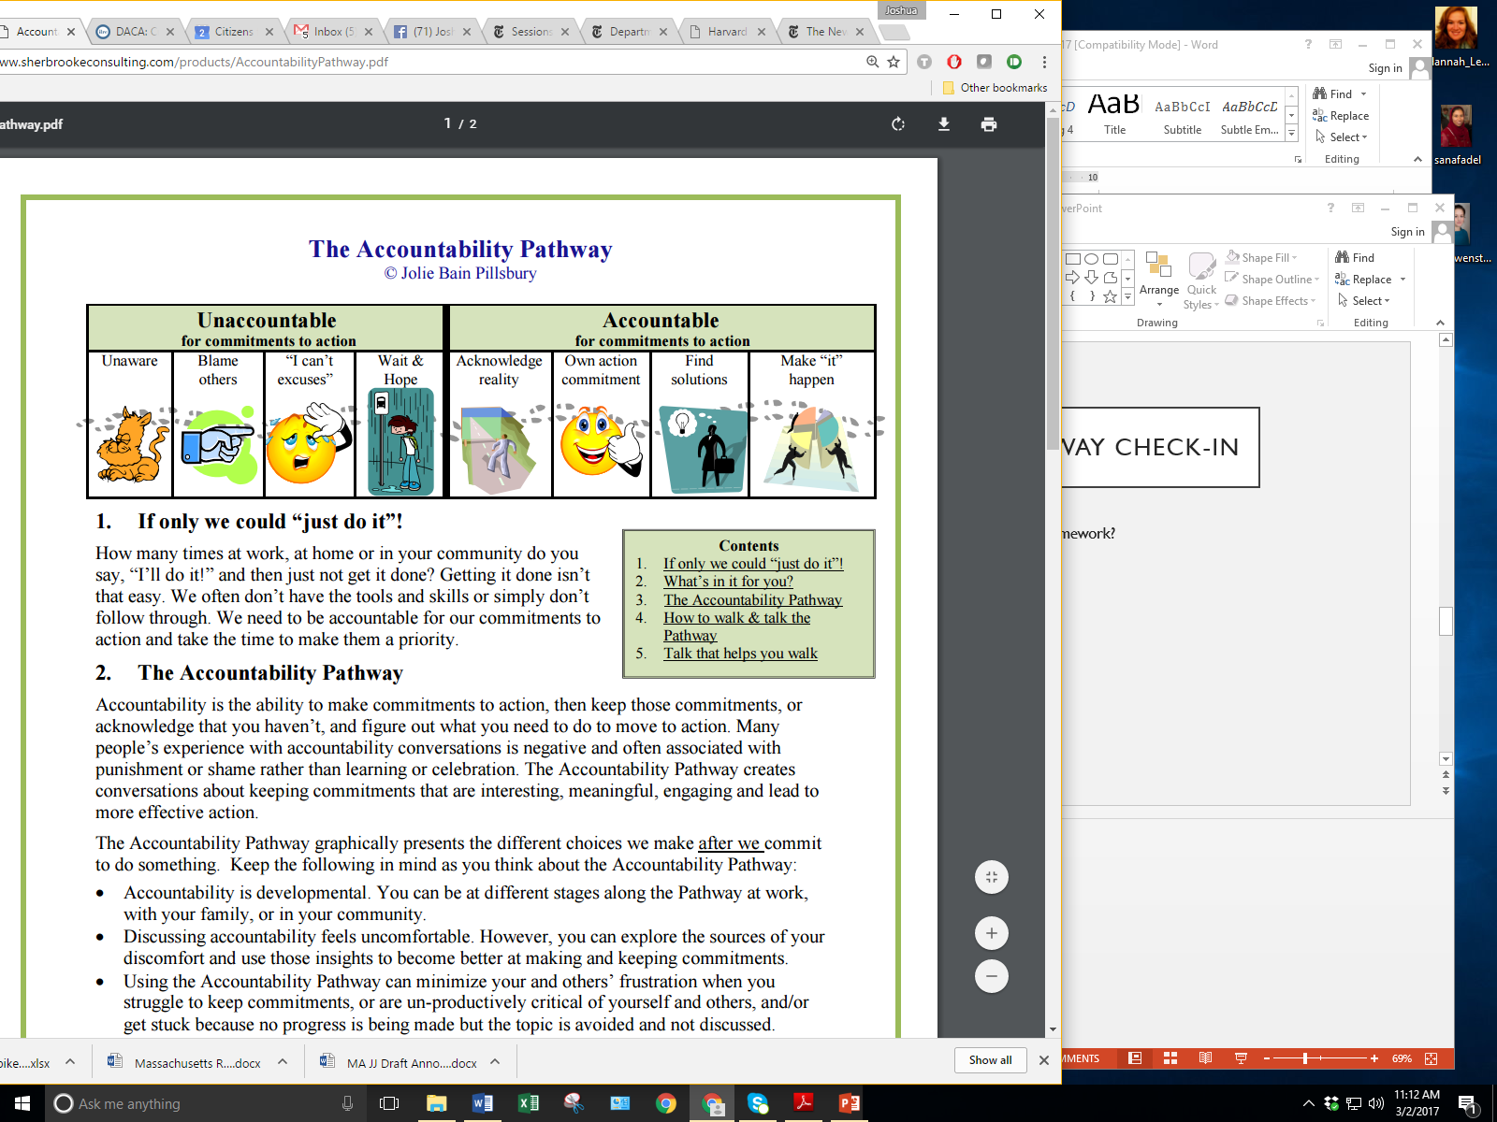

* If the conversation moves towards action steps, then encourage documentation of those steps to hold people accountable. Sample action plans are available on the JDAI website.
* Hold the group accountable for naming how a step will get done and who will do it.
* Be prepared to establish a “parking lot” for issues that are raised but may not be within the actions steps this group can take. You may find help dealing with some of these in the “Common reactions to talking about RED” sections. For instance:
  + Poverty is often raised. Current research in the area demonstrates that even when accounting for poverty there are still racial and ethnic disparities. Utilizing the parking lot validates the individuals concern and allows you to continue to facilitate the conversation towards what the group can control and reasonable action steps.
  + The point of this session is to talk about how race affects the juvenile justice system and what we can do about it– not to critique the video or to enter into a broad discussion about every manifestation of racism in America. Steer the conversation back to the core issues.

The Accountability pathway could be used in more than one location in this discussion,

I.e. accountability for your role in the system.

Choose the place that feels best for the facilitators to lead the group effectively. Link to the YouTube Video on the pathway....

**Common reactions to talking about *RED***…

*DISTRACTION -* People create committee to create the committee or having ten meetings to decide on the name of the committee or if Race will be used in the name of the committee and is that legal. Stay focused; develop work plans with timelines so you can know what is supposed to be accomplished.

**Sample action planning resources are available on the JDAI website. Some examples of National and Local Strategies which fit in the Person-Role-System framework include:**

**Person:**

* Train on ways to counteract Implicit Bias in the professional atmosphere, such as, taking Harvard’s implicit Bias tests: <https://implicit.harvard.edu/implicit/takeatest.html> and educating yourself on strategies to increase equity.

**Role**

* Use validated risk screening tools to inform your professional decision making - e.g. MASTLE, DPI, JPAST, OYAS, YLS-CMI

**System**

* Assess your organizations policies and practices through a racial equity lens.

**Tips…**

* For many people who may be new to this conversation, one session may not be sufficient to work through the material and get to action steps. For those groups encourage as a “next step” that they commit to continuing the conversation.
* The Action Plan may be used for a group collectively to make shared commitments. Alternatively, it could be provided to participants for them to fill out individually, for their private space to document what they are going to do next.

**Action Planning:** Identifying the goal, steps to achieve that goal, resources required and the timeline for completion.



**Sample Agenda for a 5.5 hour session\***

***\*This agenda is simply a suggestion and may be adjusted to better meet the needs of your agency and/or audience\****

|  |  |  |  |
| --- | --- | --- | --- |
| Time | Activity | Approximate Corresponding Slides from PowerPoint | Where in Guide |
| 90 minutes | **Introductions/Icebreaker**  **Agenda**  **Ground Rules**  **Introduction to Person, Role System** (about 1 minute per person) | 1 - 6 | Ice Breaker p. 5  Page 3 |
| 5 – 10 minutes | **Using Meaningful (local) Data** | **6 – 9**  ***(number of slides name change when customized)*** |  |
| 40 minutes | **Questions to consider while watching the video**  **Screening *Seeing RED* Film** | 10 | Discussion Questions Page 3 |
| 10 minutes | **Break/Lunch**  **May view video during lunch** | 11 | Page 4 |
| 20 minutes | **History** | 12 - 15 |  |
| 10 minutes | **Accountability Pathway** | 16 | Page 12 |
| 20 minutes | **Person:** Think, Pair, Share | 17 | Discussion Questions Page 9 |
| 20 minutes | **Role**: Small Groups | 18 | Discussion Questions Page 10 |
| 20 minutes | **System**: | 19 | Discussion Questions Page 11 |
| 10 minutes | **Break** | 20 |  |
| 60 minutes | **Revisit Accountability Pathway**  **Action Planning:** Small Groups | 21 - 23  *(may reorder the Accountability Pathway)* | Page 12 Pathway  Page 13 Action Planning  *Sample action plan on JDAI website.*  Have small group discussions to ID individual and agency action steps. |
| 10 minutes | Closing and Next Steps  (Hand out form, or do a + / Δ )  Closing |  |  |