**Satisfaction Survey QR Codes**

FRC Classes and Workshops Satisfaction Survey QR Code

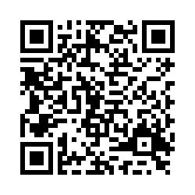

FRC Services Satisfaction Survey QR Code

