

**THE NETWORK OF FAMILY RESOURCE CENTERS**

**OPERATIONAL GUIDE**

**June 2024**



**FRC OPERATIONAL GUIDE**

1. FRC Staffing Structure 1
2. Service Flow Process Overview 6
3. Intake, Screening, Service Provision 7

* Section Overview
* Example of Prompts to Start the Conversation
* Family Intake and Additional Family Member
* Adult and Child Screening Forms
* Services Provision Form

## CRA and CRA-Related Services 9

* + Section Overview
  + Family Strengths and Needs Assessment
    - CRA and CRA-Related Indicators
    - Service Flow for Assessment
  + Family Support Plan

## Satisfaction Surveys 12

* + Family Resource Center Satisfaction Survey for Workshops and Classes
  + Family Resource Center Satisfaction Survey

## Contact Log 13

## Event Participation Forms 14

## Safety Procedures/ Protocols 14

## Incident/Grievance Reporting Procedures 14

## DCF and ASO Contacts and Structure… 15



# A. FRC STAFFING STRUCTURE

## FRC Program Director

* Manages all communications with DCF and EOHHS
* Ensures adherence to contractual obligations
* Manages the relationship with the ASO and adherence to all ASO guidelines and requirements
* Supervises the Program Manager
* Works directly with Family Members as needed
* May assume some functions of the Program Manager

## FRC Program Manager

* Responsible for the day-to-day supervision and management of FRC operations
* Ensures coordination with the FRC’s Network Service providers, manages other external community relations, and monitoring community needs.
* Provides administrative supervision for all FRC staff, including the Clinician and Family Partner
* Serves as the volunteer coordinator
* Works directly with Family Members as needed
* May assume some of the functions of the Program Director.

## FRC Clinician

The Clinician is a clinical specialist, employed by the LMHC.

* Performs trauma-informed intakes and conducts the intake, screening, and assessment functions for Family Members experiencing CRA-related issues.
* Completes the modified CANS as well as other identified supplemental behavioral needs assessments
* Oversees the development of the Family Support Plan and provides ongoing supervision and case management oversight to the Family Partner.
* Provides clinical support to other FRC staff and
* May also facilitate FRC parenting group sessions.
* May work with all Family Members who are involved with the FRC; however, Family Members experiencing CRA-related issues are prioritized for services.

## FRC Family Partner

* The Family Partner is a person from the community with “lived experience” or familiarity with CRA-related issues.
* Works in conjunction with the Clinician to complete CANS Assessments and to develop the Family Support Plans for Family Members experiencing CRA-related issues.
* Oversees the implementation of the Family Support Plan with support from other FRC staff.
* May work with all Family Members who are involved with the FRC; however, Family Members experiencing CRA-related issues are prioritized for services.



## FRC Family Support Worker

* Provides information and educational resources to Family Members
* Provides referrals to community resources
* Develops the FRC calendar
* Hosts parent and youth support groups
* Responsible for recruiting and providing support to volunteer support group facilitators

## FRC School Liaison

* Works with school districts to help Family Members navigate educational and school- related concerns and identifies Family Members that may be in need of family support services.
* Serves as a resource to families, schools, and the community
* Ensures that there is a process established to provide information, referrals, and direct assistance where possible for individual Family Members, including meetings with teachers, assistance with obtaining IEPs, and meetings with other school personnel, as necessary
* Ensures that all Family Members experiencing CRA-related issues are connected to services that meet their individual needs
* Responsible for negotiating and implementing special events and other interagency activities that involve schools.

## FRC Administrative Support Specialist (Optional)

* Provides administrative and program support
* Works with the Family Support Worker(s) to develop and manage the FRC calendar and schedule events
* Conducts informal screening of Family Members
* Provides information and referral resources to Family Members
* Reports to the Program Manager

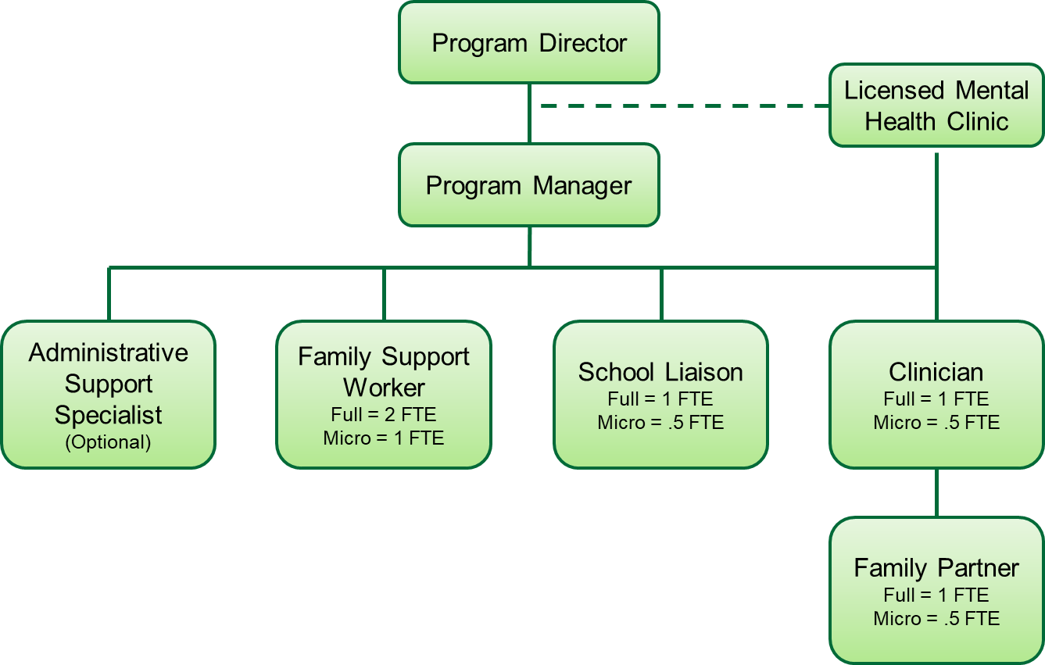



# B. SERVICE FLOW PROCESS OVERVIEW

Family members and/or youth who contact the Family Resource Centers (FRCs) by phone, email, or in-person will be greeted by any FRC staff. All FRC staff will be trained in greeting, gathering information, and directing families to the appropriate next steps. These steps are as follows:

1. FRC staff that are greeting the family/youth will have a conversation with the family and gather information to determine with the individual(s) what services and supports will help the family.
2. Complete the **Family Intake Form A** *(Section B of CRM instructions)*.
   1. Fill out as much information as the family is willing to provide, with the goal of completing the entire Form. If families are worried about sharing certain information, assure them that personal information they provide is to help the FRC staff provide them with the right supports. Reassure families that, except for mandated reporting situations, no individual or personal family information is shared without their explicit knowledge and permission.
3. Gathering information about household members who will be **receiving direct service**.
   1. FRC staff will gather Information on additional family and/or household members using **Additional Family Member Information Form B** *(Section C of CRM instructions).* This includes a child(ren)/youth or another family member and indicate for each individual whether they will receive services. Collect the necessary information to determine what the support should be.
   2. When appropriate, families will sign Release of Information Forms (to gather and release information with other providers).
4. For Family Members receiving direct services, complete an **Adult and/or Child Screening Form(s) C1 and C2** *(Section D of CRM instructions)*, use additional information from the conversation with the family member, to fill in the appropriate information on the Adult and/or Child Screening Form(s) C1 and C2*.*
5. Once the needs and concerns of the family are identified, staff will determine appropriate services and supports with the family’s input.
   1. All services and supports for each family member must be recorded on the

***Services Provision Form D*** *(Section E of CRM instructions)****.***

* 1. Basic Services can be provided by the FRC and/or by an External Network Partner.
  2. If the family is identified as Children Requiring Assistance/Families Requiring Assistance (CRA), refer the family to the **FRC Clinician and Family Partner** so that they can complete the **Family Strengths and Needs Assessment (FNSA) Form J** *(Section F of CRM Instructions).*
  3. Complete a **Family Support Plan Form K** (*Section G of CRM instructions*).



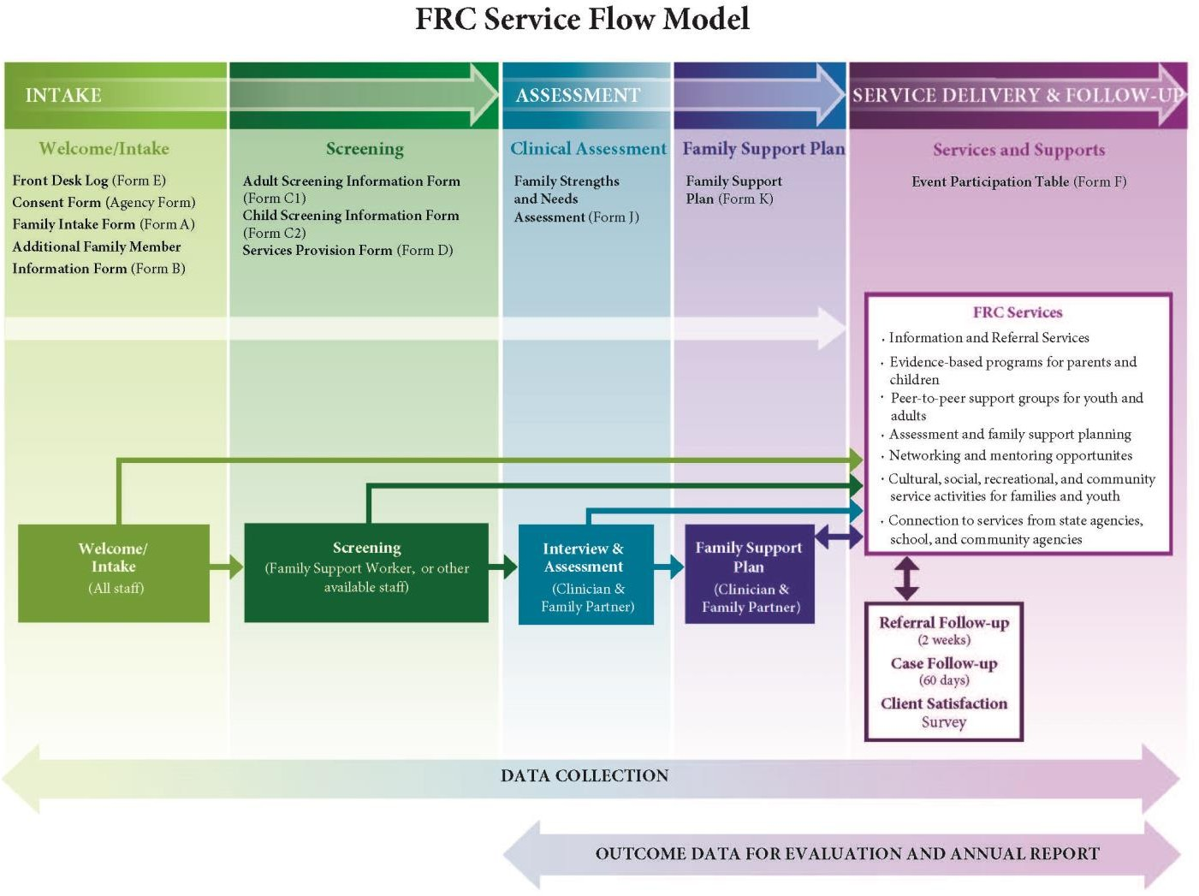

1. Families receiving services and participants of groups and classes are offered a satisfaction survey to complete.
2. Follow up with families as needed but at a minimum at 2 weeks and 60 days.



# C. INTAKE, SCREENING, SERVICE PROVISION

Families who walk-in or call will be greeted by a member of the FRC staff. The staff person will gather preliminary information on their needs and concerns, and will complete:

1. The Family **Intake Form A**
2. **Additional Family Member Intake Form(s) B** for each family member that is seeking services.
3. Complete the **Adult Screening Form C2 and the Child Screening Form C3** as more information is provided.
4. Complete the **Services Provision Form D**

If the family does not want to provide their last name or complete an Intake Form, or the inquiry is from a provider, please record their information on the **Contact Log Form E** *(Section H of CRM instructions).*

**Example Prompts to Start the Conversation**

If the family wants to participate in services and supports, ask questions so you can help them effectively.

Examples of questions to get the conversation started:

* + What brought you here today?
  + How did you hear about us?
  + What do you need right now that we can help with?

If the family came in because of their child/children:

* + How are your kids doing?
  + Are they in school?
  + How are they doing in school? At home? Are they having any problems in their community?
  + What do you need right now that we can help with for your child?

**Intake and Family Member Intake Forms**

*(Section B & C of CRM instructions)*

Fill in as much information on the **Family Intake Form A** as the family member is willing to provide. Complete a **Family Member Intake Form B** for each additional family member that is present. These forms can be filled out by any staff member. If additional family members are not present, their name, date of birth, family role and gender can be documented on page 2 of the **Family Intake Form A**.

Complete the **Family Intake Form A** with the family member.

* The Intake Form information must be entered on the FRC database (Section B of CRM instructions).
* Indicate on the Family Intake Form which of the Family Member will be receiving direct services. You will complete a Family Member Intake Form for these Family Members only.



After the initial **Family Intake Form A** is completed, please complete the **Family Member Intake Form B** for each family member in the household that will receive direct services. All family members in the household will be entered in the FRC database but only the Family Members that are receiving direct services will have “Services Needed” set at “Yes” and will have an “Initial Contact Date”.

* Initial Date is a **required field** on the database.

If there are family members not **directly** receiving a service, we still want to capture that they are a member of the household. We do this by counting them as a household member. At some point the additional household member may begin to receive services. For example, a child may get a winter coat. That child counts as a Family Member as s/he directly received the coat.

**TIP:**

* If you keep paper copies of the Intake Form, after entering the information into the CRM, copy the Family ID and the Family Member ID from the CRM onto the **Intake Form**.
  + This indicates that the family record has been created and allows easy access to the family record when updates or modifications are needed.

**Adult and Child Screening Forms**

*(Section D of CRM instructions)*

For all Family Members that are **receiving direct services**, an Adult or Child Screening form needs to be completed. If you do not start the Adult and/or Child Screening form at the initial intake, then it should be started at the second visit. Use Motivational Interviewing skills to gather the information that is relevant to the screening form. At a minimum, please complete all information on the screening form that relates to the reason(s) the family has come to the FRC. Children under the age of 6-year-old do not need a screening form. Once they reach age 6, you can complete one.

During your conversation with the family, gather as much additional information as possible. Use the questions on the **Adult and/or Child Screening Forms** to help guide the conversation to collect the information to fill in these forms. The screening forms and information will help determine what services are needed. Please see the examples below.

Examples:

* If the family member came in for help with their child(ren), ask the questions relevant to the child needing services.
* The Safety Questions should be asked of all family members requesting services.

Once the staff has the information filled out on the **Adult and/or Child Screening Forms,** the information needs to be entered the information into the CRM (FRC database).



**Services Provision Form**

*(Section E of CRM instructions)*

Once the intake and screenings are completed, the next step is to complete the **Services Provision Form D.** Identifying services is a collaborative process with the family. Below is a guide for this process.

1. The FRC staff and the family member work together to identify the needs and concerns of the family.
2. The FRC staff internally discuss options that are offered at the FRC and in the community. Based on these discussions, the family member and staff identify and select services together.
3. A **Services Provision Form D** is completed for all services referred and provided to the family member. This form is **updated whenever a family member participates in additional services***.*
   1. Each service requested is entered once in the CRM.
   2. Each time a family member returns and is provided that same service, a new date needs to be added to that service. (Section E.b. of the CRM instructions).

## D. CRA and CRA-RELATED SERVICES

Clinicians must be **certified** in the Massachusetts **Child and Adolescent Needs and Strengths (CANS)** and have experience conducting the assessment. In some circumstance, the clinician may need to conduct a full CANS when referring for mental health services. This certification is also required for conduct the **Family Strengths and Needs Assessment (FSNA),** which is the modified CANS for the FRCs.

Forms the Clinician and Family Partner will use are:

## Family Strengths and Needs Assessment (FSNA) Form J

## Family Support Plan Form K

The **Clinician** conducts the **FSNA Assessment Form J** with the family. The **Family Partner can assist** this process by providing support the family, based on family preference. Once completed the **Clinician and Family Partner** work collaboratively with the family to develop the **Family Support Plan Form K**.

**Family Strengths and Needs Assessment (FSNA)**

*(Section F of the CRM instructions)*

If it is determined that additional services are needed outside the FRC, the Clinician and/or Family Partner will request to share the **Family Strengths and Needs Assessment** with other referral sources as appropriate. In this case, the family will need to sign a release of information form.

* + **Remember**, the CRA indicators must be identified **under the youth** who is having difficulties in order to be counted in the CRA Benchmark. In the CRM, **Check the appropriate boxes on the “CRA - Related Questions”.**



**Guidance to Identify a CRA at Risk Youth:**

Per **Chapter 240**, a “**Child Requiring Assistance**,’’ is a child between the **ages of 6 and 18** who:

* Repeatedly runs away from the home of the child’s parent, legal guardian or custodian.
* Repeatedly fails to obey the lawful and reasonable commands of the child’s parent, legal. Guardian or custodian, thereby interfering with their ability to adequately care for and protect the child.
* Repeatedly fails to obey the lawful and reasonable regulations of the child’s school.
* Is habitually truant.
* Is a sexually exploited child.

For a child who has demonstrated **one (1) or more** of the following **CRA-related issues**, a **Family Strengths and Needs Assessment** and **Family Support Plan** should be completed:

* Sent by court (Family Intake Form A – Services Requested Section)
* Referred by court/probation officer (Family Intake Form A – Referral Source Section)
* Referred by DYS (Family Intake Form A – Referral Source Section)
* Suspended (Child Screening Form C2– Education/Employment Section – Educational Status dropdown list)
* Missed more than eight (8) days of school in the last 10 weeks (Child Screening Form C2 – Education/Employment Section)
* Has this child/youth been involved with a situation where he/she has been or is being exploited? (Child Screening Form C2 – Safety Section)
* Is this child involved in court (Child Screening Form C2 – Safety Section)
* Is this child/youth involved with gang? (Child Screening Form C2 – Safety Section)
* Has this child ever been detained by police or arrested where CRA is reason for detained/arrested (Child Screening Form C2 – Safety Section – Detained for what reason [dropdown list])
* Child is involved with DYS (Child Screening Form C2 –Agency Involvement Section)
* Child is involved with court (Child Screening Form C2 –Agency Involvement Section)

For a child who has **two (2) or more** of the CRA-related issues listed below, a Family Strengths and Needs Assessment and a Family Support Plan should be completed:

* Child having difficulty following rules (Child Screening Form C2 – Physical and Mental Health)
* Missed more than eight (8) days of school in the last 10 weeks (Child Screening Form C2 – Education/Employment Section)
* Child missing days at school (Family Intake Form A – Services Requested Section)
* Child ever run away (Child Screening Form C2 – Safety Section)
* Referred by school (Family Intake Form A – Referral Source Section)
* Alternative Program (Child Screening Form C2– Education/Employment Section – Educational Status dropdown list)



**Clinician and/or Family Partner will contact families that qualify for CRA services within 24 hours of receiving a referral.** The Clinician and/or Family Partner will connect with the family member to discuss their needs and concerns and set up a time to conduct **Family Strengths and Needs Assessment** with the family and youth.

* + Multiple attempts should be made to contact the family and should be documented.
  + If the family does not wish to participate in CRA services (working with the

Clinician and Family Partner to complete the **Family Strengths and Needs Assessment** and **Family Support Plan**), the FRC staff will provide information to the family member about supports and services offered at the FRC and in the community.

**TIP:** In the CRM, if the Family declines the FSNA use the “***CRA Assessment Offered – Family Member Declined****”* service provision.

If the Clinician and/or Family Partner is unable to reach the family, they will send a letter to the family letting them know that if they wish to participate in the future, they can contact the FRC. Include in the letter the FRC brochure that discusses the FRC services and contact information.

* + - If the family agrees to participate in CRA-related services, the Clinician and/or Family Partner will offer to **meet with the family within three (3) to five (5) business days**.
  + The Clinician and/or Family Partner will gather information with the family to complete the **Family Strengths and Needs Assessment** (**FSNA**). Whenever possible, the **FSNA** should be completed **within 10 days of the Clinician and Family Partner’s first meeting** with the family.
    - It is understood that sometimes relationships need time to develop and that it may take longer to gather the information and complete the assessment. Enough information should be gathered from the family to help identify needed services and supports.

**Family Support Plan**

*(Section G of CRM Instructions)*

**Note:** The Family Support Plan goes **under the parent/caregiver**.

The Clinician and/or Family Partner will complete a **Family Support Plan** with the family members.

Things to consider when conducting **family support planning**:

* + Families with many needs are often at a higher risk of feeling hopeless about anything improving. Sometimes our best intentions can contribute to this sense of hopelessness. This may happen through overly comprehensive planning. This is when a large, comprehensive plan is created to address all needs identified through the assessment process. It may not necessarily reflect the family’s priorities and can lead to plans which seem overwhelming and unrealistic.



* + Use **sequential planning**. After meeting with the family and identifying their needs through conversation and what is identified on the FSNA, prioritized the areas of need or “rank order” to reflect the family’s values, culture, and priorities. **In general, safety items are non-negotiable, and must appear in any intervention plan from the start.** But for all other items, the family should take the lead in selecting where to begin the work with the family.
  + The goal is to make progress on one or two needs as early in the process as possible. This may help the family experience some success, which builds motivation, buy-in, and hopefulness for future planning and intervention. Experience with sequential planning shows that as some key need areas are met, spontaneous improvement can occur in other areas without formal intervention.

Timing and ongoing contact:

* The Clinician and/or Family Partner will follow-up with the family within **two weeks** to ask if the family was able to participate in the services. Ongoing follow-up will be **within 30-days** of the first visit and again **within 60 days**, or more often if that is the family’s preference, to talk with them about progress towards the identified goals of the family.
* If the family continues to work with the Clinician and Family Partner on a long-term basis, follow-up **Family Strengths and Needs Assessment** should be completed at 90-day intervals.

Satisfaction Surveys and Evaluation Questionnaires:

* Please refer to the **Satisfaction Survey Section G** below.

**E. SATISFACTION SURVEYS**

It is important to gather information from youth and family members to help determine if the supports and services offered by the FRC are meeting the needs of the youth and families.

## Satisfaction Survey for Parenting Classes and Workshops

The **Satisfaction Survey for Parenting Classes and Workshops (revised 2018)** should be given on the last day of the class or at the end of the workshop. Surveys can be distributed either as a paper copy, in a video chat, sent via email or text.

The facilitator will:

1. Distribute paper copies of the survey and pens/pencils to participants. If your FRC has an iPad for entry, you may offer that as a method. If the class or workshop is conducted remotely (i.e. Zoom) post a link to the survey in the chat or offer to email or text the link to participants.
2. If providing paper copies:
   1. check off which program or workshop the survey is for prior to distributing to participants; or



* 1. instruct the participants which program to check off.
  2. Pass a large manila envelope around for people to return their surveys in.
  3. Send the completed surveys to UMass Chan for UMass Chan staff to enter.

1. Let people know that their **responses are anonymous**.
2. If the class/workshop is in-person, it’s encouraged that attendees to do the surveys on paper. However, make all methods available sot that the attendee can complete it the way that they prefer.

## Satisfaction Survey for Services

**The *Satisfaction Survey for Services*** should be offered to any family/individual who has any of the following:

* A Family Strengths and Needs Assessment (Family Strengths and Needs Assessment)
* A Family Support Plan
* A Screening Form
* Participation in support group
* Intake form plus minimum of 2 services
* Only one adult member of a family should complete the survey.
* The person completing the survey can complete a paper version or an online version.
* If available, screen readers can be used on the online versions for those who have trouble reading.
* The family will be asked to complete follow-up evaluation questionnaires/surveys within **two (2) months** of the family’s first formal contact with the FRC, and then again in three (3) month increments for as long as the if the family is willing to participate and still engaged with the FRC.

**F. CONTACT LOG**

*(Section H of the CRM Instructions)*

When a provider, community partner, school, or other entity calls or visits the FRC, you want to document that information on the **FRC Contact Log Form E**. On the **Contact Log** capture:

* Date and Time
* Name of Parent/Caregiver or Agency
* Reason for contact or visit
* Who should be contacted? (If follow-up is required)
* Release signed if needed
* Contact information

If the person making the call or visit is a parent/caregiver, make the effort to engage the individual/family and if appropriate, conduct an intake. If you complete an intake, **do not** document the interaction in the Contact Log. Start a New Family in the CRM.



If the parent/caregiver does not complete and intake, **do document** the interaction in the

## Contact Log.

**G. EVENT PARTICIPATION FORMS**

*(Section I of the CRM Instructions)*

**Event Participation Form F** should be completed for every event that occurs at the Family Resource Center. The information that you will document include:

* Indicate if the event was a collaborative event (if “Yes”, then fill in the entity’s information)
* Event Date (required)
* Select the Event Name (*there is a drop-down menu in the CRM*)
* The Actual Name of The Event - the name may not match the name on the drop- down list on the CRM, just type in the name in the open text. (Required)
* Staff member(s) in charge of the event and their roles
* Total number of sessions and current session (e.g., Parenting Journey may be a 12-week program, total number of sessions would be 12, current session might be session 4)
* Indicate if childcare, food and/or transportation were provided
* Number of people registered (if registration was required)
* Number of people who attended *or* the number estimated attended; only select one of the choices
* Number of children who received child care
* Sign in sheets should be collected, except if the event is an anonymous group (then only numbers will be documented)

If the family member is also enrolled in your FRC and has a **Family Intake Form A or B**, the event information needs to also be added to their **Services Provision Form D**. For example, a family member is attending Parenting Journey as part of their service provision. Their attendance will be documented on the **Event Participation Form F** *and* the **date of attendance** should be documented on the Service Provision Form D under the Family Member that attended.

**H. SAFTEY PROCEDURES/ PROTOCOLS**

FRCs must have Safety Procedures and Protocols in place. Managers and Directors will review these procedures and protocols with newly hired FRC staff as part of their onboarding at your FRCs. They should also be reviewed with all FRC staff annually at a minimum. These must include policies and protocols on:

* + Facility Safety Plan (e.g., lighting, area security, etc.)
  + Communication Plan (e.g., who initiates contact with staff, communication tree, etc.)
  + Staffing Safety Plan (e.g., minimum number of FRC staff during open hours, etc.)

**I. INCIDENT/GRIEVANCE REPORTING PROCEDURES**

FRCs Staff must have an Incident and Reporting Procedure in place. These procedures need to be in compliance with your contracting agency’s policies. Each of the incidents listed below must be report to FRC leadership (FRC Manager and/or Director). The FRC



Manager and/or Director include in their procedure a communication reporting the event to the DCF Community Support Manager for that region (See Section J for Contact).

At a minimum, these procedures must include reporting on event that either take place in the FRC, impact an FRC Family and/or Family Member who are receiving FRC services, or involve FRC staff.

For Families and Family Members:

* + Death of a Caregiver or Youth; or the suicide of a Caregiver or Youth
  + Injury of Family or Youth at the FRC.
  + Any situation where a DCF-involved FRC Family experiences a safety issue, injury, or fatality
  + Any FRC family member who experiences a life-threatening safety incident
  + Any situation where law enforcement gets involved in an FRC safety issue
  + Family Grievances.
    - The FRC must have a process in place for working with families and youth who have grievances related to the supports and services they are receiving from the FRC.

For FRC Staff:

* + Injury of a Staff Member at the FRC.
  + If staff at an FRC files a 51a
  + If there is a breach in FRC confidential information protection (i.e. Personal Health Information (PHI), Personally Identifying Information (PII), etc.
  + Any safety situation that will involve the media
  + Any community safety issue where the FRC is involved in the response (fires, floods, etc.)
  + FRC Staff Grievances.
    - The FRC must have a process in place for staff to be able to report grievances to FRC management and/or the parent agency human resource department.

**J. DCF AND ASO STRUCTURE**

The Massachusetts Department of Children and Families (DCF) works in partnership with the Administrative Service Organization (ASO) at ForHealth Consulting at University of Massachusetts Chan Medical School to support the work for the Family Resource Centers.

|  |  |
| --- | --- |
| **DCF Contacts** | |
| Jose Monteiro [jose.monteiro@mass.gov](mailto:jose.monteiro@mass.gov) | Jolanta Rumierz [jolanta.rumierz@mass.gov](mailto:jolanta.rumierz@mass.gov) |
| Maroli Licardie [Maroli.Licardie2@mass.gov](mailto:Maroli.Licardie2@mass.gov) | Daniel Lewis [daniel.lewis@mass.gov](mailto:daniel.lewis@mass.gov) |
| Megan Tully  [megan.j.tully@mass.gov](mailto:kate.darmetko@mass.gov) | Lissette Rodriguez [Lissette.Rodriguez@mass.gov](mailto:Lissette.Rodriguez@mass.gov) |
| Colleen Pritroni [colleen.pritoni@mass.gov](mailto:colleen.pritoni@mass.gov) | Ricky Newton [Ricky.Newton@mass.gov](mailto:Ricky.Newton@mass.gov) |
| **ASO Contacts** | **Federation for Children with Special Needs** |
| Jen Fishman [Jennie.Fishman@umassmed.edu](mailto:Jennie.Fishman@umassmed.edu) | Renee Williams  [rwilliams@fcsn.org](mailto:rwilliams@fcsn.org) |
| [FRCHelp@umassmed.edu](mailto:FRCHelp@umassmed.edu) |  |



