Administrative Service Organization (ASO) – Family Resource Center
Frequently Asked Questions

Table of Contents
I. General Program Related Questions 2
II. ASO Provided Accounts 2
a. @Community-Family.org Account 2
b. FRC CRM Database 3
c. Tableau 3
d. FRConnect 3
III. FRC Marketing and Materials 3
a. Brand Identity/Logos 3
b. Ordering Brand Materials 4
c. FRConnect News & QuickConnect Newsletter 4
IV. FRC Trainings 4
a. Upcoming FRC Trainings 4
b. Submitting a FRC Training Requests and Registration Form: 4
c. Important Notes: 5

General Program Related Questions
Below are frequently asked questions related to the overall FRC program.
- Where do I find all the Workplan documents and recorded TA sessions?
  - The FRC Workplan folder in FRConnect.
- I want my site’s calendar posted to FRCMA.org and FRConnect.
  - Email your site’s calendar to FRCHelp@umassmed.edu.
- I have a staff member recently hired, changed positions, or resigned.
  - FRC Program Director or Manager must submit a FRC Staff Changes and Updates Form as soon as possible.
- I need one of the FRC Standard Forms or Satisfaction Surveys in a non-English language.
  - See FRC Standard Form folder in FRConnect.
- Can I have the Satisfaction Survey QR codes?
  - See FRC Standard Form folder in FRConnect.
- I need specific data to help manage my center, for my workplan, for my parent agency, or for applying to a grant.
  - Submit a Data Request Form.

ASO Provided Accounts
Below are frequently asked questions related to accounts provided to the FRC network by the ASO.

@Community-Family.org Account
- Can I have a password reset?
  - You can reset your @Community-Family.org account password. For step-by-step instructions, see the Community-Family Homepage Sign in Instructions or the ‘Section V. Forgot Your Password and Cannot Sign in’ webinar in FRConnect’s “Community and Family Account – CRM, Tableau, and SSO Information” folder.
- I do not have access to my Multi-Factor Authentication method registered to my account.
  - Contact FRCHelp@umassmed.edu.
- I forgot my password and no longer have access to my Multi-Factor Authentication method registered to my account.
  - Contact FRCHelp@umassmed.edu.
- When I sign in, I get an error message that my account is blocked.
  - Double check you are signing into https://myapps.microsoft.com/ using your @Community-Family.org account. If you are and still receiving this error message, please provide FRCHelp@umassmed.edu with the error message you see.

FRC CRM Database
- Can I register for a CRM Training?
  - The CRM Training schedule and registration link is communicated via email to FRC Directors and Managers. Another way to check for an upcoming training is look at the Training tab in FRConnect.
  - Note only FRC funded positions can access the CRM. To obtain access to the system, we will need a FRC Staff Changes and Updates Form submitted by the center’s Director or Manager as well as the staff member’s attendance at the full 2-hour training.
- I need to attend a CRM Training, but I am not available to attend the upcoming scheduled training.
  - Contact FRCHelp@umassmed.edu.
- I found a family/family member in the CRM that has more than 1 record. Could we merge these accounts together?
  - Provide FRCHelp@umassmed.edu with the Family and Family ID numbers of the accounts you need merged. Make sure to identify the ‘Primary’ and ‘Secondary’ accounts. This means ‘Family Information’ tab and ‘Family Member Info’ tab details on the ‘Primary’ accounts will be saved, while the ‘Secondary’ account’s will be deleted. Additional records added to Family and Family Member accounts will all be merged; none will be deleted. This includes, but is not limited to, Service Provisions, Screenings, and Family Support Plans.
- Can we have a data field edited or a record deleted?
  - Provide FRCHelp@umassmed.edu with details about the field that need to be edited or deleted (i.e., delete the 1/14/2024 Event Participation titled Parenting Journey). When applicable, please include the Family ID or Family Member ID number.
  - Please do not email any Personal Identifying Information, such as names and birthdates. Only email the Family ID or Family Member ID.

Tableau
- My site’s data reports do not look accurate.
  - Contact FRCHelp@umassmed.edu with more details on what you are seeing.
- Can I have the detailed data behind the numbers I am seeing in my Tableau report?
  - Yes! Please submit a Data Request Form.

FRConnect
- I forgot my account sign in information; username and/or password.
  - Contact FRCHelp@umassmed.edu.

FRC Marketing and Materials
Below are frequently asked questions related to the FRC network marketing and branding.

Brand Identity/Logos
- Where do I find the FRC Brand Style Guide, flyers in non-English languages, FRC logos, etc.?
  - The FRC Brochure, Logo and Brand Identity folder in FRConnect.

Ordering Brand Materials
- Can I have more swag/brochures/flyers?
  - Contact FRCHelp@umassmed.edu.

FRConnect News & QuickConnect Newsletter
- I want my center’s event information posted in FRConnect News.
  - Submit the event’s information through FRConnect. If there are any flyers or photos, please submit them to FRCHelp@umassmed.edu. Note we will need to confirm all persons in a photo signed a release form.
- I want my pet photo featured in the QuickConnect Newsletter.
  - Submit your pet photo(s) and your pet’s name(s) to FRCHelp@umassmed.edu.

FRC Trainings
Below is information regarding FRC trainings, like FRC Orientation and Parenting Journey, and how to register for them.

Upcoming FRC Trainings
- Staff that are interested in trainings should refer to the ‘Training Opportunities Description’ document linked under the Training tab in FRConnect. This document provides:
  - A description of the trainings
  - The date and time the training is offered
  - The date that registration closes for that training
  - Link to the FRC Training Requests and Registration Form

Submitting a FRC Training Requests and Registration Form:
- Select the training/agency you are interested in
- Depending on the training you will be prompted to select a specific training (i.e., Nurturing Fathers, Parenting Journey I, etc.)
- Enter dates you are interested in. If there are no dates available, enter to be waitlisted
- Enter trainee’s information
- Enter supervisor’s information
- Select “I agree” to the final question, hit the arrow.
- A “thank you” message will display on the screen. An example of the message is displayed below and receiving this message means your form was fully submitted.
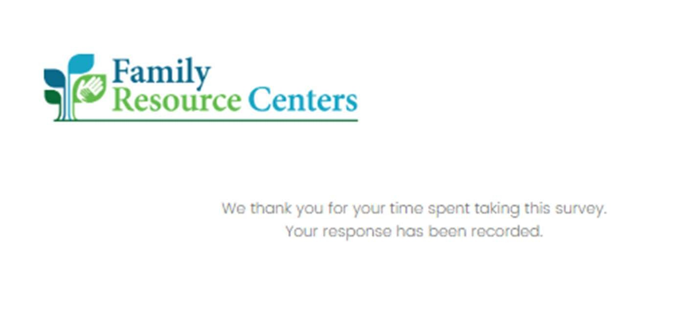

Important Notes:
      - Registrations close 2.5 weeks prior to the training date.
      - If you start a form, but do not complete it, please refresh the survey, especially when completing forms for multiple trainings or staff, as it will begin where it left off.
      - Forms must be completed in full to be considered submitted for pre-registration.
      - Upon receiving the thank you confirmation after your submission, please do not submit another form.
      - Please do not submit forms for each FRC Orientation session.
      - Staff that have registered will receive an email from UMass staff to confirm their pre- registration after the registration close date.
      - Confirmation emails for the training sessions will be sent to staff that pre- registered once registration is closed, please respond to the email confirming if you are able to attend. A new form will not be required.
      - You or your staff must confirm they are attending the training to keep their seat.

